Calculus 3 Lecture 13.9: Constrained Optimization with LaGrange Multipliers

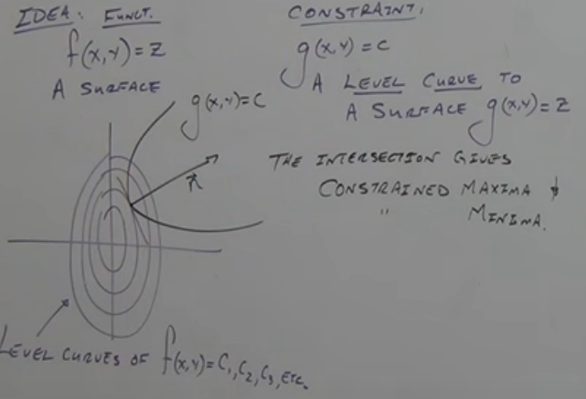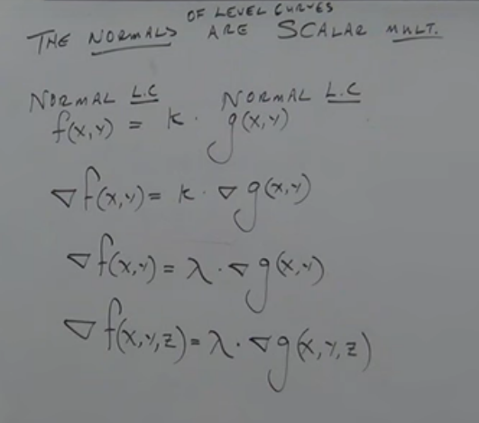
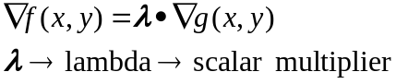

Example
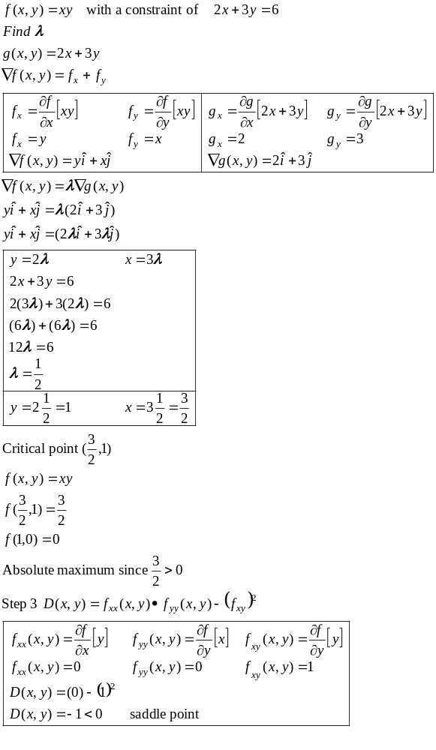
Absolute Maximum and Minimum points will be found when using Lambda.

Example
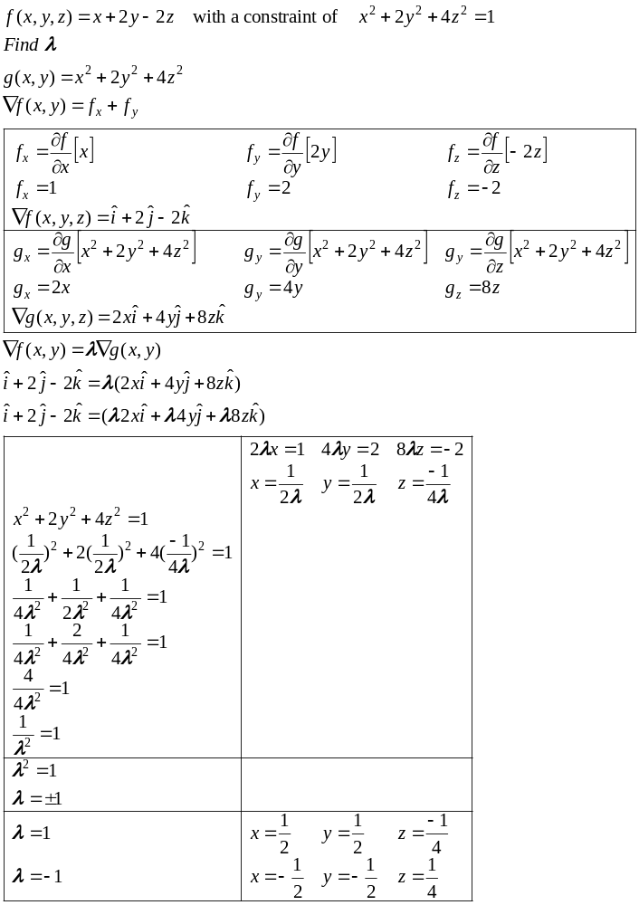

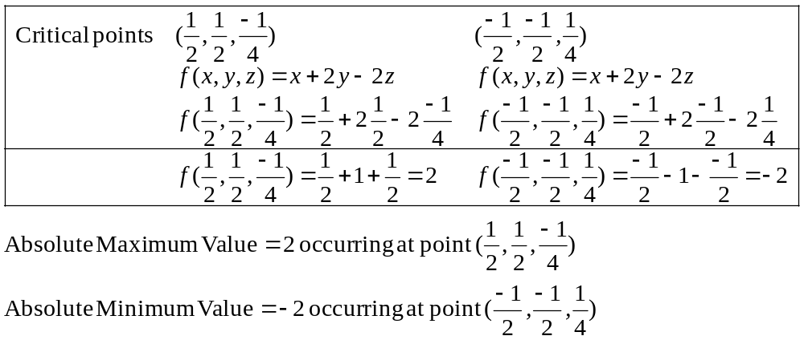
Example
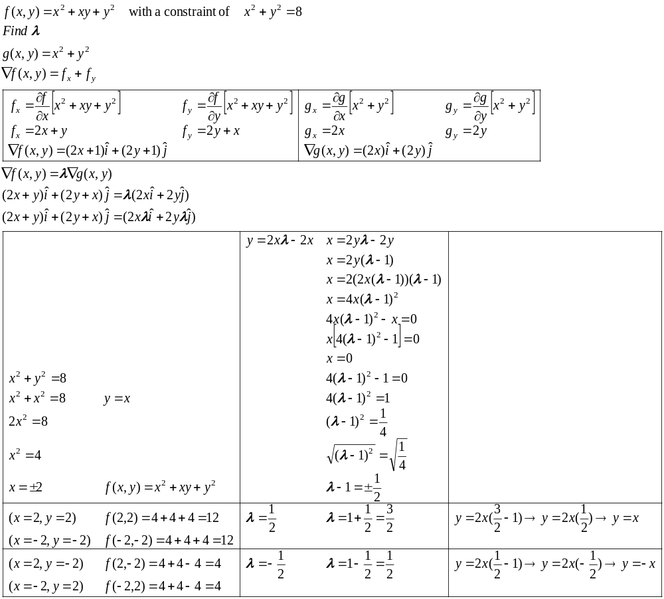Maximum Value 12 at P(2,2) and P(-2,-2)
Minimum Value 4 at P(-2,2) and P(2,-2)

